Write Verilog and Testbench Code to Implement a 4:1 Multiplexer
Aim
To design, implement, and simulate a Full adder using two half adders Verilog HDL and verify its operation using a testbench in Quartus Prime and QuestaSim.
Objective
After completing this experiment, students will be able to:
- To understand the operation of a Half Adder and Full Adder.
- To implement a Full Adder using two Half Adder modules.
- To write Verilog HDL code using hierarchical modelling.
- To verify all possible input combinations using a testbench.
- To simulate the design in QuestaSim.
Theory:
A Full Adder is a combinational digital circuit used to perform the addition of three binary input bits. The three inputs are A, B, and Carry-in (Cin). It produces two outputs: Sum and Carry-out (Cout).
A Full Adder can be implemented using two Half Adders and one OR gate.
Working
First Half Adder:
The first Half Adder adds the two inputs A and B.
- Intermediate Sum:
S1 = A ⊕ B
- Intermediate Carry:
C1 = A · B
Second Half Adder:
The second Half Adder adds the intermediate sum S1 with the input carry Cin.
- Final Sum:
Sum = S1 ⊕ Cin
- Intermediate Carry:
C2 = S1 · Cin
OR Gate:
The two carry outputs are combined using an OR gate.
- Cout = C1 + C2
Therefore, the complete Full Adder equations are:
Sum = A ⊕ B ⊕ Cin
Cout = AB + Cin(A ⊕ B)
Block Diagram
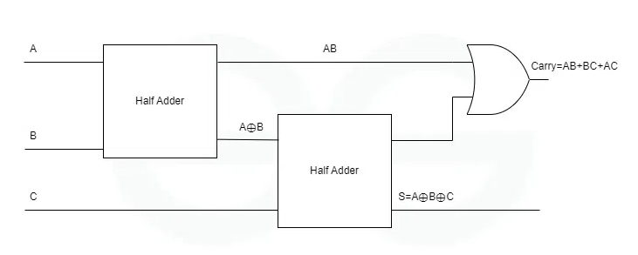

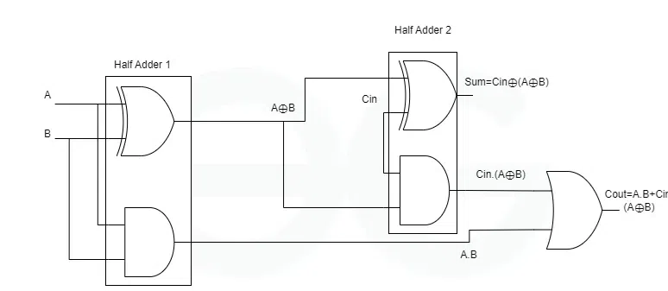

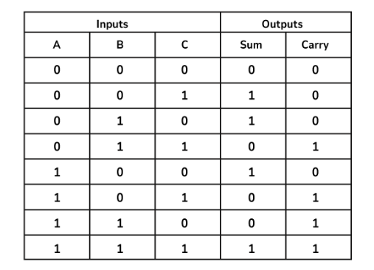
Truth Table

Algorithm
- Start the program.
- Define the inputs A, B, and Cin and outputs Sum and Cout.
- Design the first Half Adder (HA1):
- Add inputs A and B.
- Generate intermediate sum S1 = A XOR B.
- Generate intermediate carry C1 = A AND B.
- Design the second Half Adder (HA2):
- Add intermediate sum S1 and input carry Cin.
- Generate final Sum = S1 XOR Cin.
- Generate intermediate carry C2 = S1 AND Cin.
- Combine the two carry outputs using an OR gate:
- Cout = C1 OR C2.
- Apply all eight possible combinations of A, B, and Cin through the testbench.
- Observe the Sum and Cout outputs.
- Compare the simulation results with the Full Adder truth table.
- If all outputs match the truth table, the Full Adder operation is verified successfully.
- Stop.

Verilog Code (Design Module)

A).Half Adder

Save this file as half_adder.v.

module half_adder(

input A,

input B,

output Sum,

output Carry

);

assign Sum = A ^ B;

assign Carry = A & B;

endmodule

B).Full Adder Using Two Half Adders

Save this file as full_adder.v.

module full_adder(

input A,

input B,

input Cin,

output Sum,

output Cout

);

wire S1;

wire C1;

wire C2;

// First Half Adder

half_adder HA1(

.A(A),

.B(B),

.Sum(S1),

.Carry(C1)

);

// Second Half Adder

half_adder HA2(

.A(S1),

.B(Cin),

.Sum(Sum),

.Carry(C2)

);

// Final Carry

assign Cout = C1 | C2;

endmodule

Testbench
Save this file as full_adder_tb.v.
module full_adder_tb;

reg A;
reg B;
reg Cin;
wire Sum;
wire Cout;

// Instantiate Full Adder
full_adder DUT(
.A(A),
.B(B),
.Cin(Cin),
.Sum(Sum),
.Cout(Cout)
);
initial begin
$dispaly(“A,B,Cin,Sum,Cout”);

$monitor("%b %b %b %b %b", A, B, Cin, Sum, Cout);
A = 0; B = 0; Cin = 0; #10;
A = 0; B = 0; Cin = 1; #10;
A = 0; B = 1; Cin = 0; #10;
A = 0; B = 1; Cin = 1; #10;
A = 1; B = 0; Cin = 0; #10;
A = 1; B = 0; Cin = 1; #10;
A = 1; B = 1; Cin = 0; #10;
A = 1; B = 1; Cin = 1; #10;
$finish;
end
endmodule

Simulation Procedure (Quartus Prime & QuestaSim)
- Open Intel Quartus Prime.
- Create a new project using File → New Project Wizard.
- Add the following Verilog files:
- half_adder.v
- full_adder.v
- full_adder_tb.v
- Set full_adder as the top-level design entity for synthesis.
- Compile the project using Processing → Start Compilation.
- Check that there are no compilation errors.
- For simulation, configure QuestaSim as the simulation tool.
- Use full_adder_tb as the simulation top-level module.
- Start QuestaSim.
- Compile the Verilog files.
- Start simulation and add A, B, Cin, Sum, and Cout to the waveform.
- Run the simulation for at least 80 ns.
- Compare the waveform with the truth table.

Expected Simulation Result
A | B | Cin | Sum | Carry
0 | 0 | 0 | 0 | 0
0 | 0 | 1 | 1 | 0
0 | 1 | 0 | 1 | 0
0 | 1 | 1 | 0 | 1
1 | 0 | 0 | 1 | 0
1 | 0 | 1 | 0 | 1
1 | 1 | 0 | 0 | 1
1 | 1 | 1 | 1 | 1
Observation
The Full Adder was successfully designed and implemented using two Half Adders in Verilog HDL. The design was simulated using a testbench, and all eight possible combinations of inputs were verified successfully in QuestaSim. The simulated outputs matched the Full Adder truth table.
Applications
A Full Adder is an important combinational circuit used in digital systems for binary addition. Its major applications are:
- Binary Adders
- Ripple Carry Adder
- Arithmetic Logic Unit (ALU)
- Microprocessors and Microcontrollers
- Digital Signal Processing
- Counters and
- Address Generation
- Multipliers
Advantages
- Simple Design
- Modular Structure
- Easy Implementation
- Suitable for Multi-bit Addition
- Easy Verification
- Reusable Design
- Useful in Digital Systems
Viva Questions
- What is a Full Adder?
- What is the Sum and carry equation?
- What is a Half Adder?
- What is the limitation of a Half Adder?

